

Help with paying for immediate and essential dental treatment

Introduction
If you qualify, you can get help with up to one thousand dollars a year (any 52-week period) for immediate and essential dental treatment. You don’t have to pay this money back.
The Ministry of Social Development (MSD) may be able to help. MSD includes Work and Income and StudyLink, who provide services for individuals and whānau (families) throughout New Zealand.


Do you qualify?

To qualify, you need to:
- be 16 or over;
- be a New Zealander (citizen or permanent resident);
- live in New Zealand;
- have an immediate and essential need for dental treatment.

It also depends on:
- how much you and your partner earn;
- any money or assets you and your partner have;
- what type of dental treatment you need help with.

What you can get help with
Work and Income or StudyLink can help pay for immediate and essential dental treatment, which can include:
- extractions;
- fillings for tooth restorations (except for cosmetic or for non-oral health issues);
- root canal treatments (except for molar teeth);
- treating infections.

It does not include:
- regular check-ups;
- cosmetic treatments;
- teeth cleaning – unless it’s for gum infections;
- cast restorations;
- orthodontic treatments;
- molar root canal treatments;
- dentures.

Help with dentures
If you need help with dentures, there are other ways we can help, such as:
- recoverable assistance; or an
- advance payment of benefit; or
- talking with us.

How much you can get
You can apply more than once a year, up to a total of one thousand dollars for the period. You don't have to apply for all the assistance at once. You don't have to pay this money back.
If you need help with more than one thousand dollars in a year, talk with Work and Income or StudyLink. There might be other ways we can help.

How to apply

Step 1: Visit your dentist (or the health agency completing the dental treatment)
Your dentist or health agency needs to complete a Dental Treatment Information form. They will already have this form and will fill it in when they examine you. The form tells us key information that we need.
The form asks for:
- what dental treatment you need;
- how much it will cost;
- the dentist’s details;
- anything else that your dentist wants to say.

Step 2: Apply to Work and Income or StudyLink
There are different ways to apply:
- Applying in MyMSD.
- Visiting a Work and Income service centre.
- Calling Work and Income or StudyLink.
When you apply, we’ll go through the next steps with you. This includes how you can pay your dentist if your application is approved.

How to apply in MyMSD
If you have MyMSD it’s easy to apply there.
- Log in (https://my.msd.govt.nz) to your MyMSD account.
- Select ‘Apply’.
- Select ‘I need help with a one-off cost’.
- Select ‘Medical and dental’, then select ‘Dental costs’.
- Upload a photo of your Dental Treatment Information form.
- Answer the questions about your situation.
- Search for your dentist by adding them as a ‘supplier’.
- Finish the application.
When you’re done, check MyMSD again in 45 minutes for our response.

Description of image below: MyMSD is open on a computer, and the ‘Apply’ page is open. There are three options available, and the ‘I need help with a one-off cost’ option is being selected by the computer mouse.

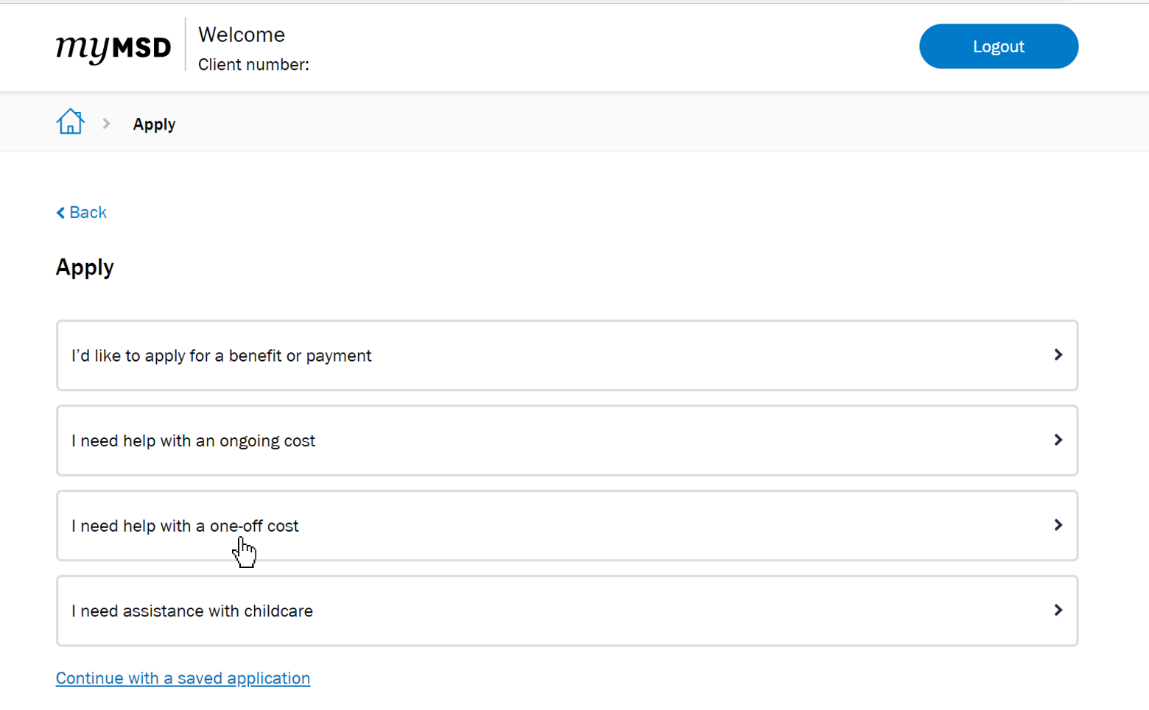

Description of image below: The ‘Apply for one-off costs’ page in MyMSD is open. The ‘Medical and Dental’ costs category is open and there is a list of different types of costs. The option ‘Dental costs’ has been selected.

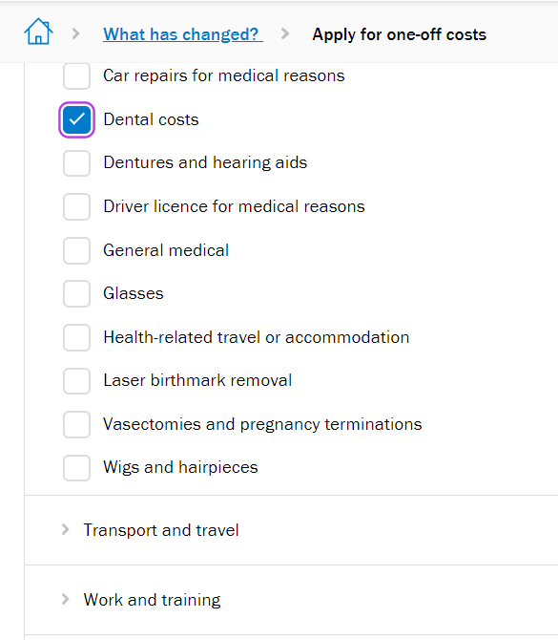

How to apply in person
To apply in person, you can visit your local Work and Income service centre. Bring your completed Dental Treatment information form with you. You can also bring a support person with you if you like.
To find your local Work and Income service centre, you can visit this webpage: Find a service centre - Work and Income (https://workandincome.govt.nz/findus)

How to apply over the phone
If you’re 18 to 64:
You can call us:
- Monday to Friday, 7am to 6pm.
- Saturday, 8am to 1pm.
Phone number: 0800 559 009.
If you’re over 65:
You can call us:
- Monday to Friday, 7am to 6pm.
- Saturday, 8am to 1pm.
Phone number: 0800 552 002.
Phone us - Work and Income (https://workandincome.govt.nz/phone)

If you’re a student with StudyLink:
You can call us:
- Monday to Friday, 7am to 6pm.
- Saturday, 8am to 1pm.
Phone number: 0800 88 99 00.
Phone us - StudyLink (https://studylink.govt.nz/phone)
If you’re deaf, hard of hearing, or have a speech impairment (or find it hard to communicate by phone):
You can contact us on:
- Text: 029 286 7170
- Email: MSD_Deaf_Services@msd.govt.nz
You can also contact us through NZ Relay: nzrelay.co.nz

For more information
Dental treatment - Work and Income https://workandincome.govt.nz/dental-treatment

End of information: Help with paying for immediate and essential dental treatment

