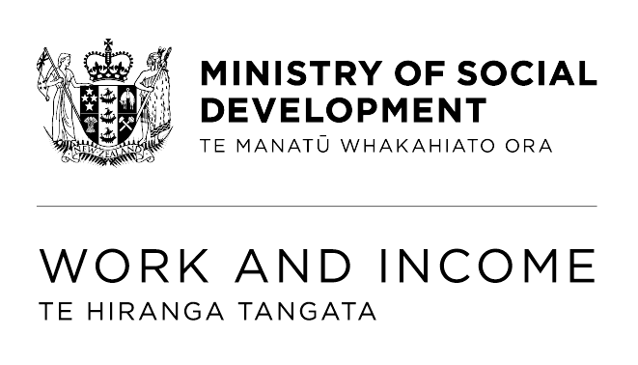
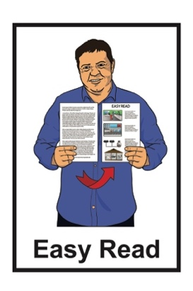

Information about the

Work and Income

traffic light system
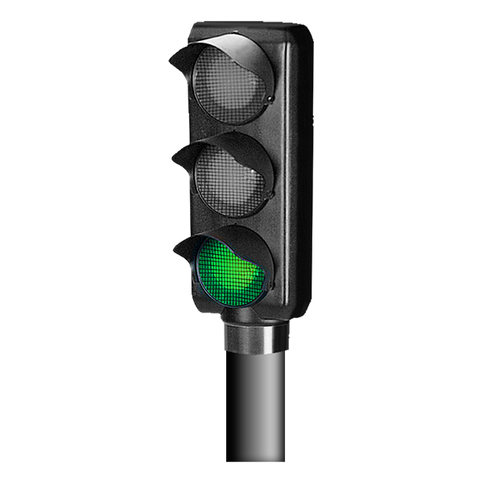
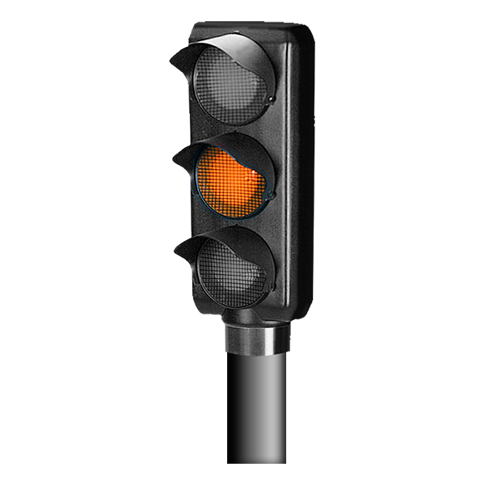
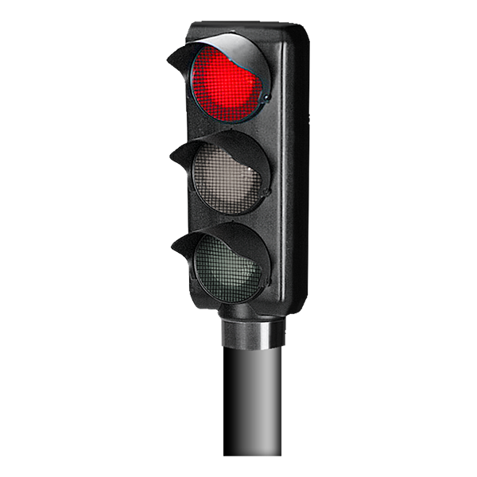

Updated: July 2025

What is in here

Page number:
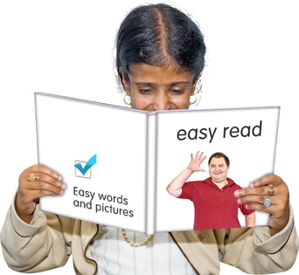

About this Easy Read 2

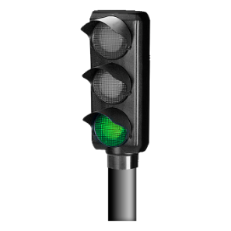
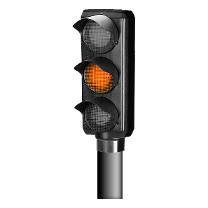
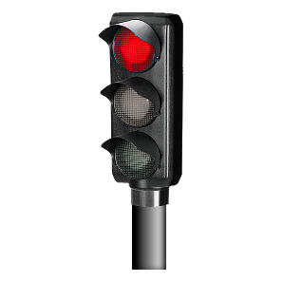
What is the traffic light system? 3

Who is the traffic light system for? 6

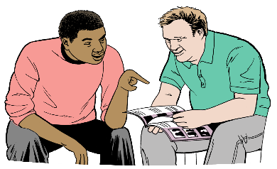
How does the traffic light
system work? 14

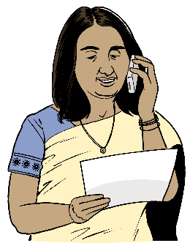
Your other obligations 19

How to talk with us 21

About this Easy Read

This document is from the Ministry of Social Development – Te Manatū Whakahiato Ora.

It is about the traffic light system being used for some types of benefits from Work and Income – Te Hiranga Tangata.

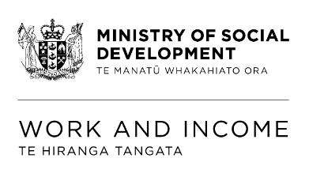
In this document Work and
Income – Te Hiranga Tangata will be called Work and Income.

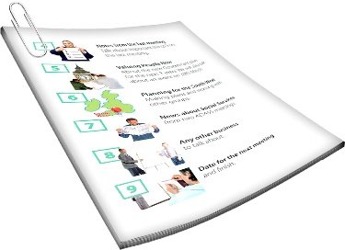
Where it says we / our this means Work and Income.

What is the traffic light system?

The traffic light system is part of the way you keep your benefit if you are on:
Jobseeker Support
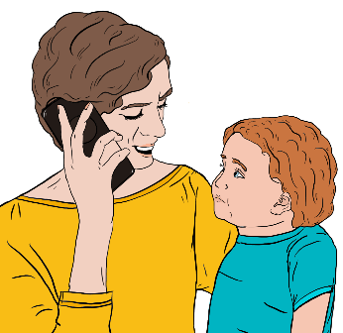
or
Sole Parent Support.


You may also be in the traffic light system if you are on:
Emergency Benefit


or

Emergency Maintenance Allowance.

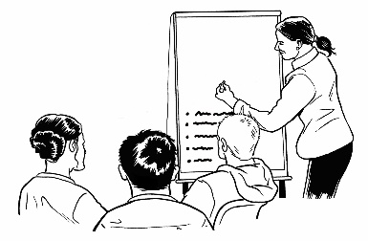
The traffic light system is an easy way for you to know if you are on track for your:

work-related obligations
social obligations.


At Work and Income work-related obligations means you are expected to:
look for work
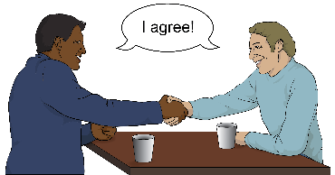
take any offer of work you can do that is:

- full time
- part time
- temporary / for a short time.


At Work and Income your social obligations are about if you care for children.

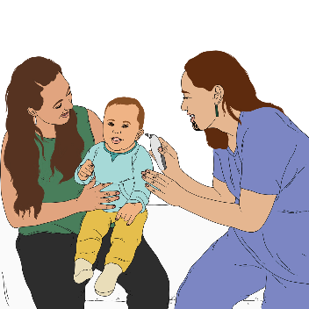
You must make sure
your children are getting:
health checks
education like going to school.

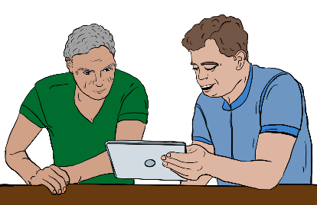
If you get off track with your obligations we will:
tell you what you need to do
support you to get back on track.

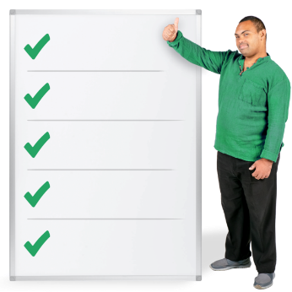
Your obligations will be made clear to you from the start.


There is more information on pages 14 to 18 about how the traffic light system works.

Who is the traffic light system for?

The traffic light system is for everyone who has:

work-related obligations
social-obligations.

Work related obligations mean you need to:
find work
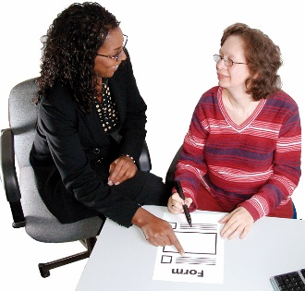
get ready for work
take part in Work Ability Assessments
take part in activities with our service providers.

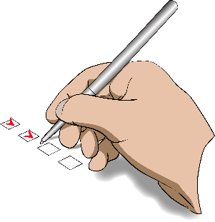
A Work Ability Assessment is a type of test that shows Work and Income what kind of work you can do.

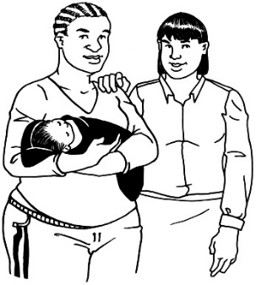
Your obligations will be different if you:
are getting the Youth Payment
are getting the Young Parent Payment
have a youth coach.


You can find out more about these obligations under youth activities at this website:

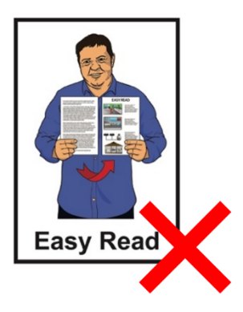
www.youthservice.govt.nz/
trafficlights

This website is not in Easy Read.

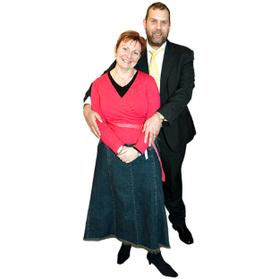
If you have a partner they may have obligations too.

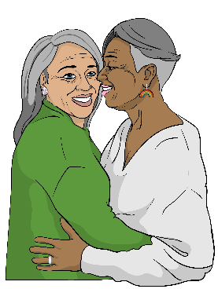
Here a partner means someone you are:
married to

in a relationship with like a:
- boyfriend
- girlfriend.
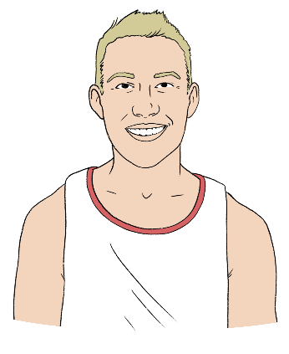

If your partner is under 18 years old they will have youth activity obligations.

This means your partner:
is in the traffic light system
and
will have different obligations to you.

You / your partner may also have obligations if you get the:
Emergency Benefit

Emergency Maintenance Allowance.

If you have children you take care of you have social obligations under the traffic light system.

Go to page 19 to find out more information about your obligations.


Supported Living Payment

Most people who get Supported Living Payment are not in the traffic light system.

This is because they do not have an obligation to find work.


If you get Supported Living Payment you will only be in the traffic light system if:
you are taking care of children
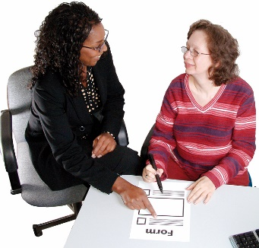
we have asked you to take a Work Ability Assessment
we have asked you to work with a service provider.



If you get Supported Living Payment you will only be in the traffic light system if:
it has been assessed that you can prepare for work
and
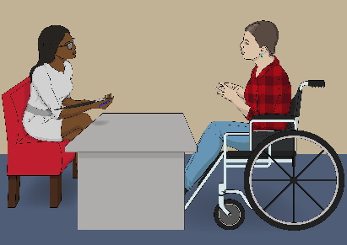
we have talked about this with you.


If you have a partner their obligations are likely to be different.

This means they could be in the traffic light system even if you are not.

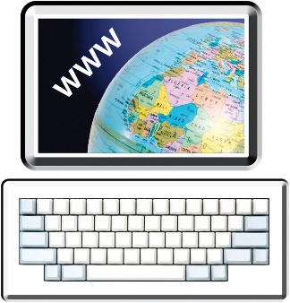
You can find out more about your other obligations for the Supported Living Payment at this website:

tinyurl.com/343dkwth
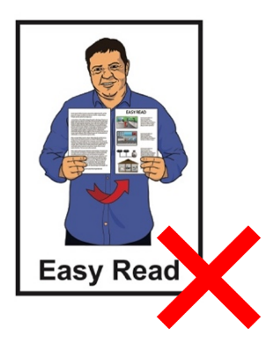

This website is not in Easy Read.

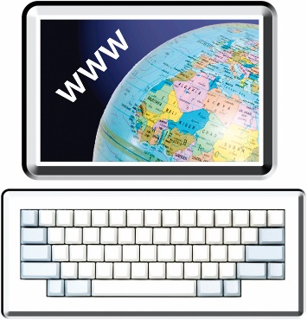
If you have a partner you can find out more about the other obligations they have if you are on the Supported Living Payment at this website:

tinyurl.com/3uefb9sp

This website is not in Easy Read.

How does the traffic light system work?

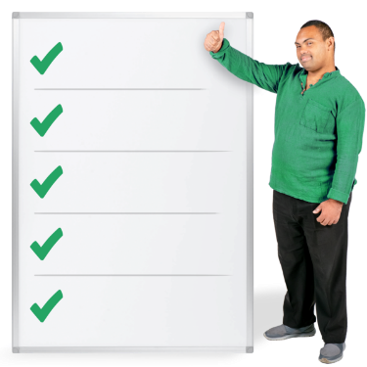
The traffic light system lets you know:
where you are at
what you need to do.

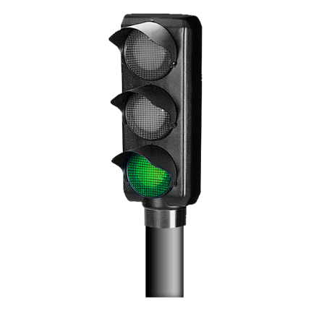
Green

If you are at green you are:
on track
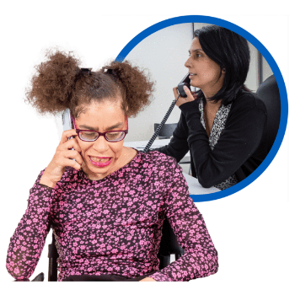
doing your obligations.

If there is any reason why you cannot do your obligations you should talk to us straight away.


We will try to talk to you before we move you to orange.

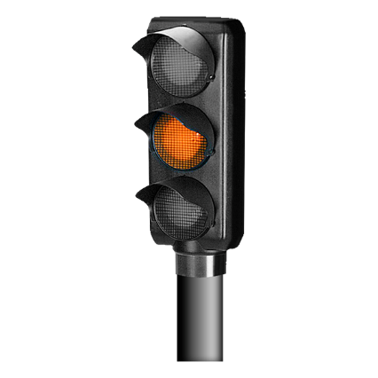
Orange

We will send you a letter to let you know we have moved you to orange.

We will move you to orange if you:
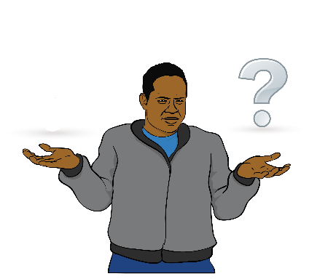

do not meet your obligations
and
do not have a good reason why this has happened.

This means you need to talk to us straight away.



You will be moved to red if you do not:
talk to us

and
get back on track in 5 working days.

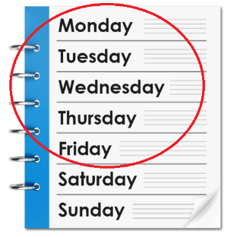
The working days in a week are Monday to Friday.

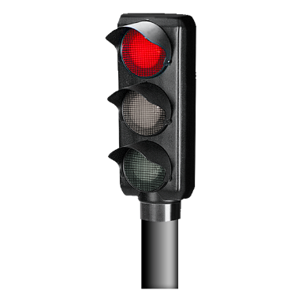
Red

We will send you a letter to let you know we have moved you to red.

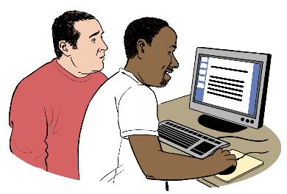
You can also see what traffic light colour you are at in MyMSD.

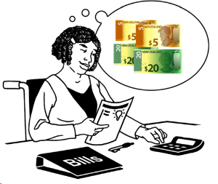

If you are at red your benefit could:
reduce

or
stop.

You need to talk to us straight away if your benefit has been:
reduced
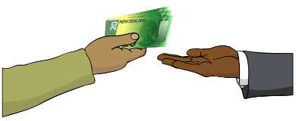

or
stopped.


Traffic light system at MyMSD
You can see in MyMSD what traffic light colour you are at.



You can login to MyMSD at this website:

tinyurl.com/2evhyxte
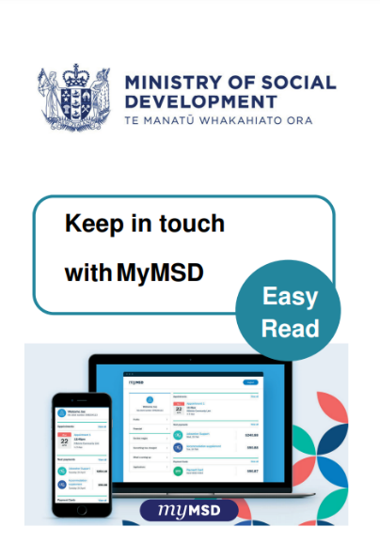

You can find Easy Read information about MyMSD at:

www.workandincome.govt.nz/documents/online-services/mymsd-easy-read.pdf

Your other obligations

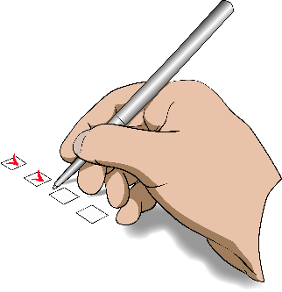
You will have other obligations if you or your partner are getting payments from Work and Income.


You can find out what these other obligations are at this website:

tinyurl.com/yeew56kv

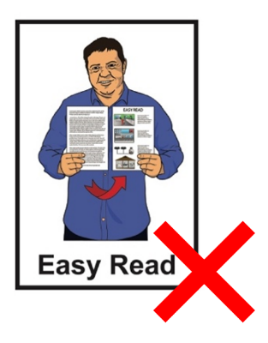
This website is not in Easy Read.

You can find out what happens if you or your partner do not meet your obligations at this website:

tinyurl.com/284t5xva

This website is not in Easy Read.

How to talk with us

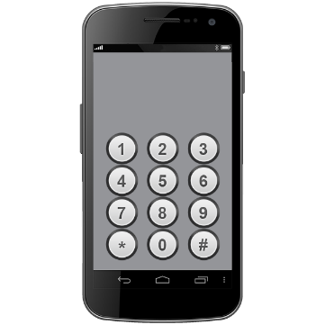
You can talk with Work and Income by phone on:

0800 559 009

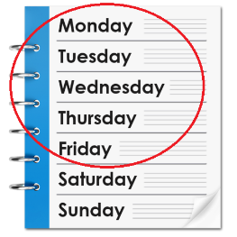
You can call us on:
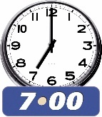
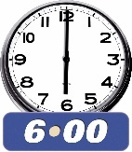
Monday to Friday from:
- 7 am to 6 pm
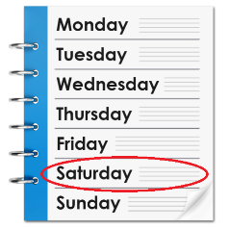
Saturday from:
- 8 am to 1 pm.
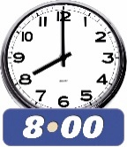
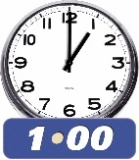

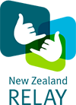
If you find it hard to use the phone the New Zealand Relay service is for people who are:
Deaf / hard of hearing
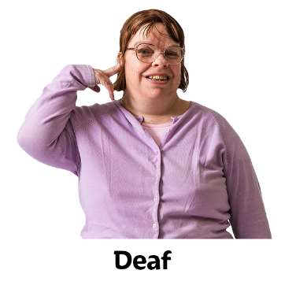
deafblind
speech impaired / find it hard to talk.

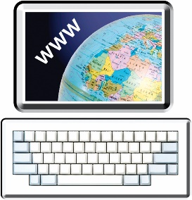
You can find out more about the New Zealand Relay service at:

www.nzrelay.co.nz

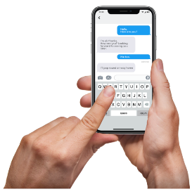
You can also text on:

4206

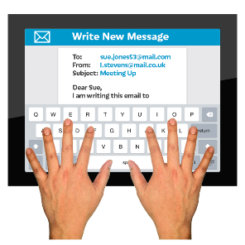
You can also email at:

MSD_Deaf_Services@msd.govt.nz
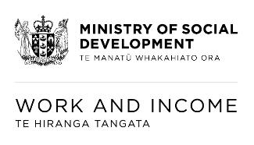
This information has been written by the Ministry of Social Development – Te Manatū Whakahiato Ora.


It has been translated into Easy Read by the Make it Easy Kia Māmā Mai service of People First New Zealand Ngā Tāngata Tuatahi.

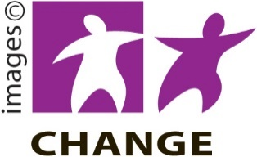
The ideas in this document are not the ideas of People First New Zealand Ngā Tāngata Tuatahi.

Make it Easy uses images from:


- Changepeople.org


            - Photosymbols.com

- SGC Image Works
- Huriana Kopeke-Te Aho

- T. Wood.

All images used in this Easy Read document are subject to copyright rules and cannot be used without permission.

